

OCEANIS 50 FAMILY

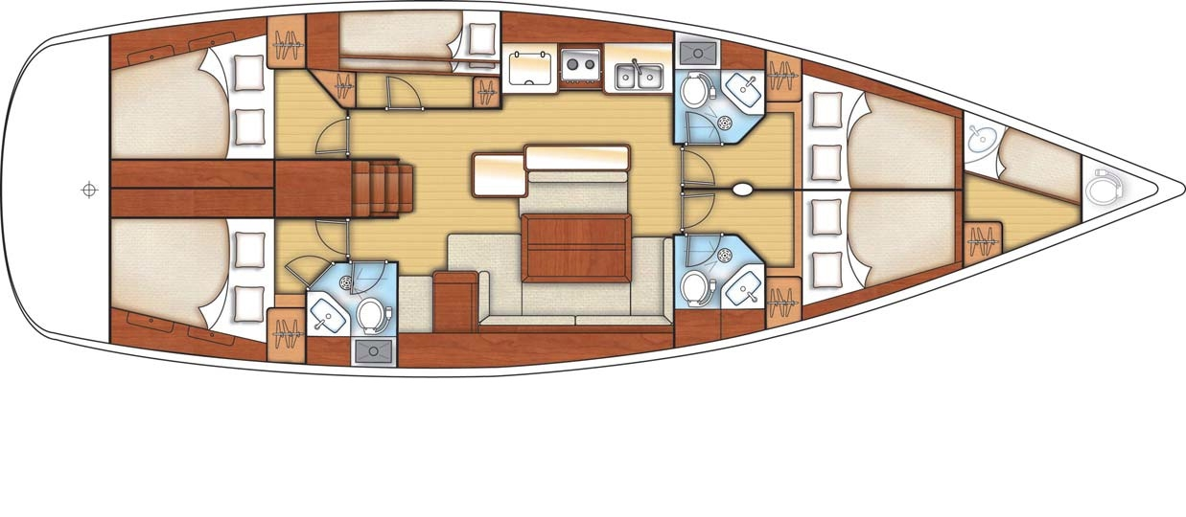

YEAR 2011/2012

Length overall 15,42 m | Draft 2,00 m
Beam 4,82 m | Engine 75 HP Sail Drive
Weight 12,7 T | Mainsail 63,10 m²
Water capacity 980l | Genoa 54,70 m²
Fuel capacity 400 l
EQUIPMENT  - Tender  - Bimini top  - Sprayhood  - Hot water  - Cockpit table  - Roll main sail and roll genoa | ELECTRICAL EQUIPMENT  - GPS chart plotter  - Autopilot  - Speed and echo log  - Wind instrument  - VHF  - Radio-CD player  - Electric windlass  - Bow thruster
OUTSIDE  - 2 winch handles  - 2 anchors with chain  - ropes  - 6 fenders  - boat hook  - wind direction indicator  - life bouy  - 2 gas bottles  - byboat pump  - water nose + brush  - bilge pump + handle | INSIDE  - charts  - plotters + divider  - hand bearing compass  - binoculars  - pilot books  - life jackets  - first aid kit  - portable lamp  - tools  - clock + barometer  - kitchen equipment

