

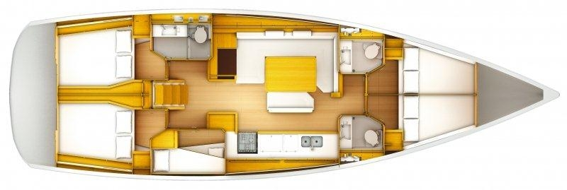

SUN ODYSSEY 509

YEAR 2012

Length overall 15,38 m | Draft 2,28 m
Beam 4,69 m | Engine Yanmar 75 HP
Weight 13,9 t | Mainsail m²
Water capacity 615 l | Genoa m²
Fuel capacity 240 l | Spinnaker m²
EQUIPMENT  - Tender  - Bimini top  - Spray hood  - Bow thruster  - Hot water  - Cockpit table  - Roll main sail and roll genoa | ELECTRICAL EQUIPMENT  - GPS with plotter  - Autopilot  - Speed and echo log  - VHF  - Radio-CD player  - Electric windlass  - Wind instrument
OUTSIDE  - 2 winch handles  - 2 anchors with chain  - Ropes  - 6 fenders  - Boat hook  - Wind direction indicator  - Life buoy  - 2 gas bottles  - byboat pump  - Water nose + brush  - Bilge pump + handle | INSIDE  - charts  - plotters + divider  - hand bearing compass  - binoculars  - pilot books  - life jackets  - first aid kit  - portable lamp  - tools  - clock + barometer  - kitchen equipment

