

OCEANIS 45- 4 cabins

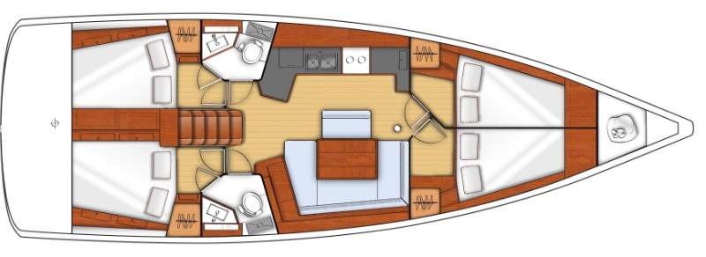

YEAR 2016/2017
Length overall 13,94 m | Draft 2,27 m
Beam 4,50 m | Engine Yanmar 54 HP
Weight 10,5 t | Mainsail 50 m²
Water capacity 370 l+200l | Genoa 50 m²
Fuel capacity 200 l
EQUIPMENT  - Tender  - Bimini top  - Sprayhood  - Hot water  - Cockpit table  - Roll main sail and roll genoa  - Teak cockpit | ELECTRICAL EQUIPMENT  - GPS with chart plotter  - Autopilot  - Speed and echo log  - VHF  - Radio-CD player  - Electric windlass  - Wind instrument  - Bowthruster  - Heating
OUTSIDE  - 2 winch handles  - 2 anchors with chain  - ropes  - 6 fenders  - boat hook  - wind direction indicator  - life bouy  - 2 gas bottles  - byboat pump  - water nose + brush  - bilge pump + handle | INSIDE  - charts  - plotters + divider  - hand bearing compass  - binoculars  - pilot books  - life jackets  - first aid kit  - portable lamp  - tools  - clock + barometer  - kitchen equipment

