

SUN ODYSSEY 379

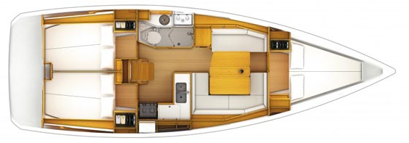

YEAR 2015 PERFORMANCE

Length overall 11,34 m | Draft 1,95 m
Beam 3,76 m | Engine 29 HP
Weight 6,7 t | Main sail 35m²
Water capacity 330 l | Genoa 35 m²
Fuel capacity 130 l
EQUIPMENT  - Tender  - Hot water  - Cockpit table  - Standard main sail X-grid Mylar /Taffeta  - Roll genoa X-grid Mylar/Taffeta  - Electric windlass  - Bimini top  - Sprayhood  - Bowthruster  - Folding propeller  - Steering wheels made of composit material | ELECTRICAL EQUIPMENT  - GPS with plotter in cockpit  - Autopilot  - Speed and echo log  - VHF  - Radio, USB PORT  - Wind instrument
OUTSIDE  - 2 winch handles  - 2 anchors with chain  - ropes  - 6 fenders  - boat hook  - wind direction indicator  - life bouy  - 2 gas bottles  - byboat pump  - water nose + brush  - bilge pump + handle | INSIDE  - charts  - plotters + divider  - hand bearing compass  - binoculars  - pilot books  - life jackets  - first aid kit  - portable lamp  - tools  - clock + barometer  - kitchen equipment

