

BAVARIA Cruiser 34
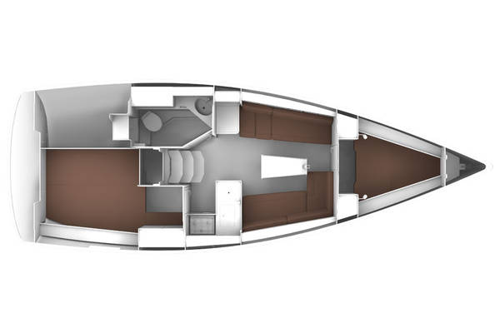

YEAR 2017
Length overall 9,99 m | Cabins 2
Beam 3,42 m | Berth 4 + 2
Displacement 5200 kg | Draft 2,05 m
Water capacity 150 l | Engine Volvo Penta 30 HP saildrive
Fuel capacity 150 l | Height in salon 1,84m
EQUIPMENT  - Tender  - Hot water  - Cockpit table  - Roll main sail and roll genoa  - Electric windlass  - Bimini top  - Sprayhood | ELECTRICAL EQUIPMENT  - GPS with plotter in cockpit  - Autopilot  - Speed and echo log  - VHF  - Radio-CD player  - Wind instrument
OUTSIDE  - 2 winch handles  - 2 anchors with chain  - ropes  - 6 fenders  - boat hook  - wind direction indicator  - life buoy  - 2 gas bottles  - Tender pump  - water nose + brush  - bilge pump + handle | INSIDE  - charts  - plotters + divider  - hand bearing compass  - binoculars  - pilot books  - life jackets  - first aid kit  - portable lamp  - tools  - clock + barometer  - kitchen equipment

