

SUN ODYSSEY 440

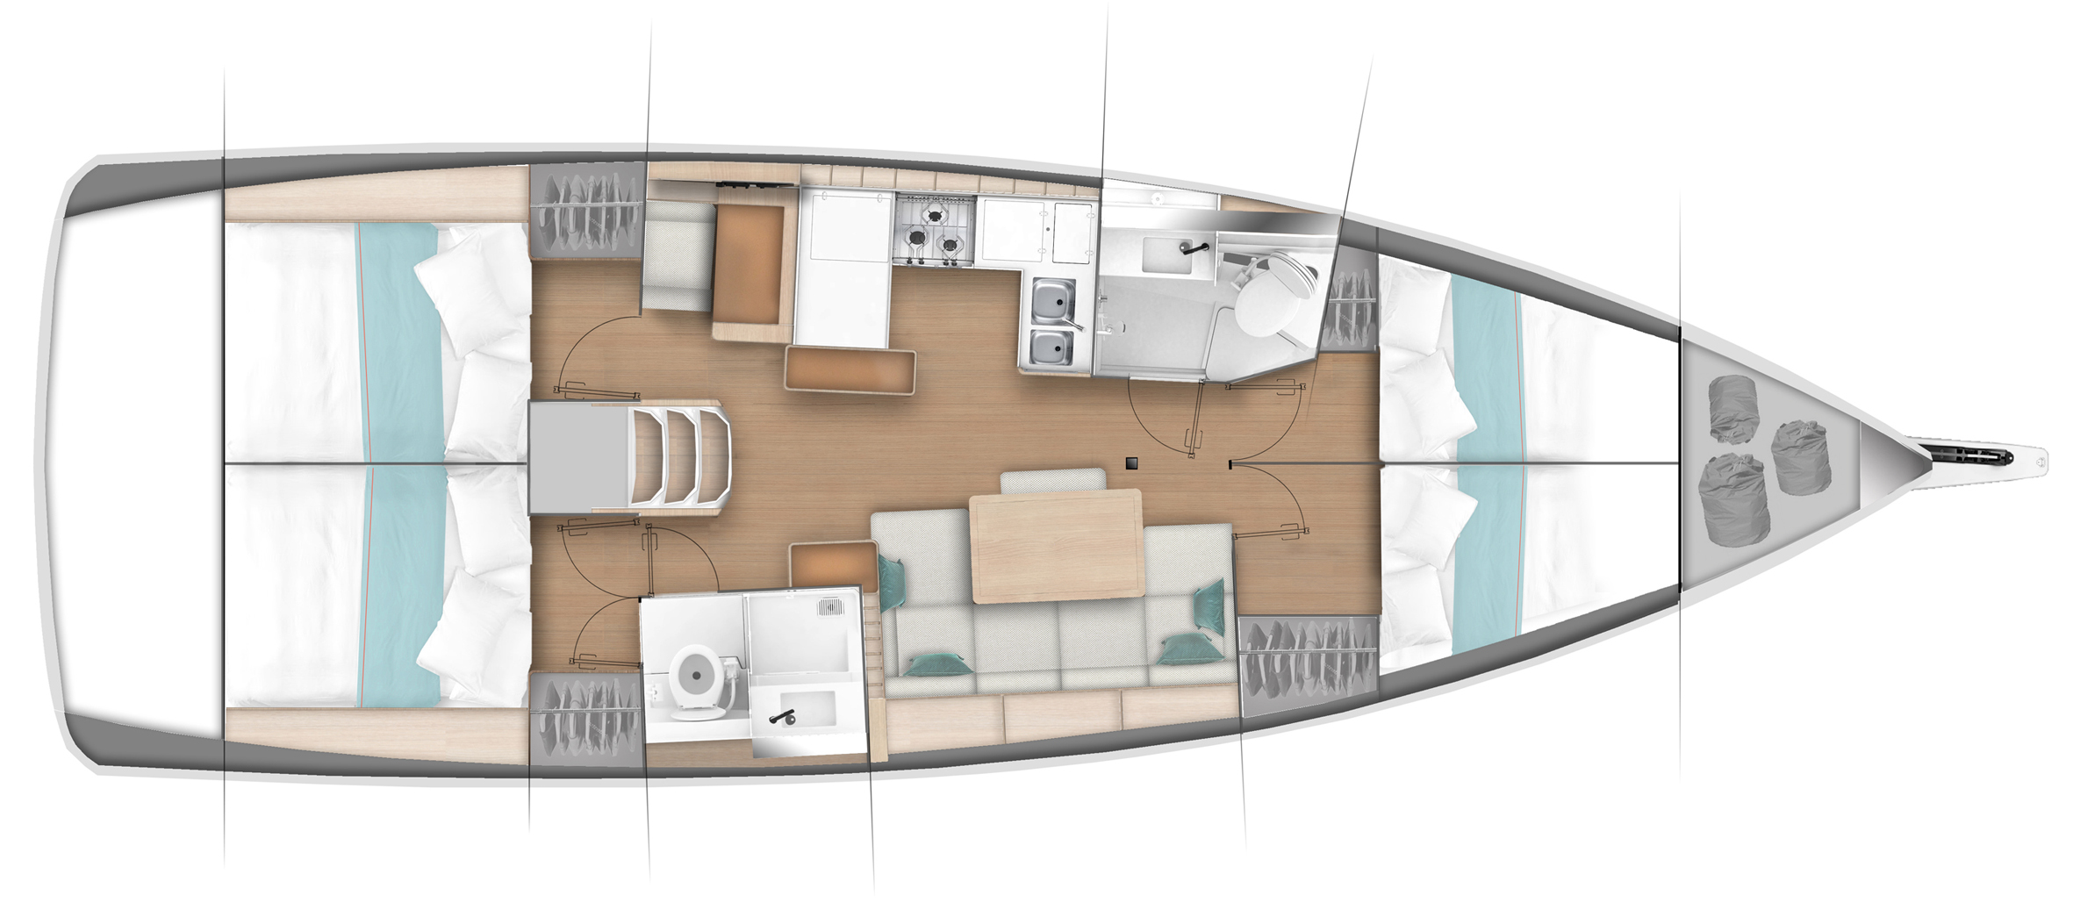

YEAR 2019

Length overall 13,00 m | Draft 2,20 m
Beam 4,29 m | Engine HP
Weight 9,88 t | Mainsail m²
Water capacity 330 l | Genoa m²
Fuel capacity 200 l | Fridge capacity 130l
EQUIPMENT  - Tender  - Hot water  - Cockpit table  - Roll main sail and roll genoa  - Electric windlass  - Bimini top  - Sprayhood | ELECTRICAL EQUIPMENT  - GPS with plotter in cockpit  - Autopilot  - Speed and echo log  - VHF  - Radio-CD player  - Wind instrument  - Bow thruster  - Air condition  - Generator 3,5kW & watermaker on request
OUTSIDE  - 2 winch handles  - 2 anchors with chain  - ropes  - 6 fenders  - boat hook  - wind direction indicator  - life bouy  - 2 gas bottles  - byboat pump  - water nose + brush  - bilge pump + handle | INSIDE  - charts  - plotters + divider  - hand bearing compass  - binoculars  - pilot books  - life jackets  - first aid kit  - portable lamp  - tools  - clock + barometer  - kitchen equipment

