

BAVARIA Cruiser 46
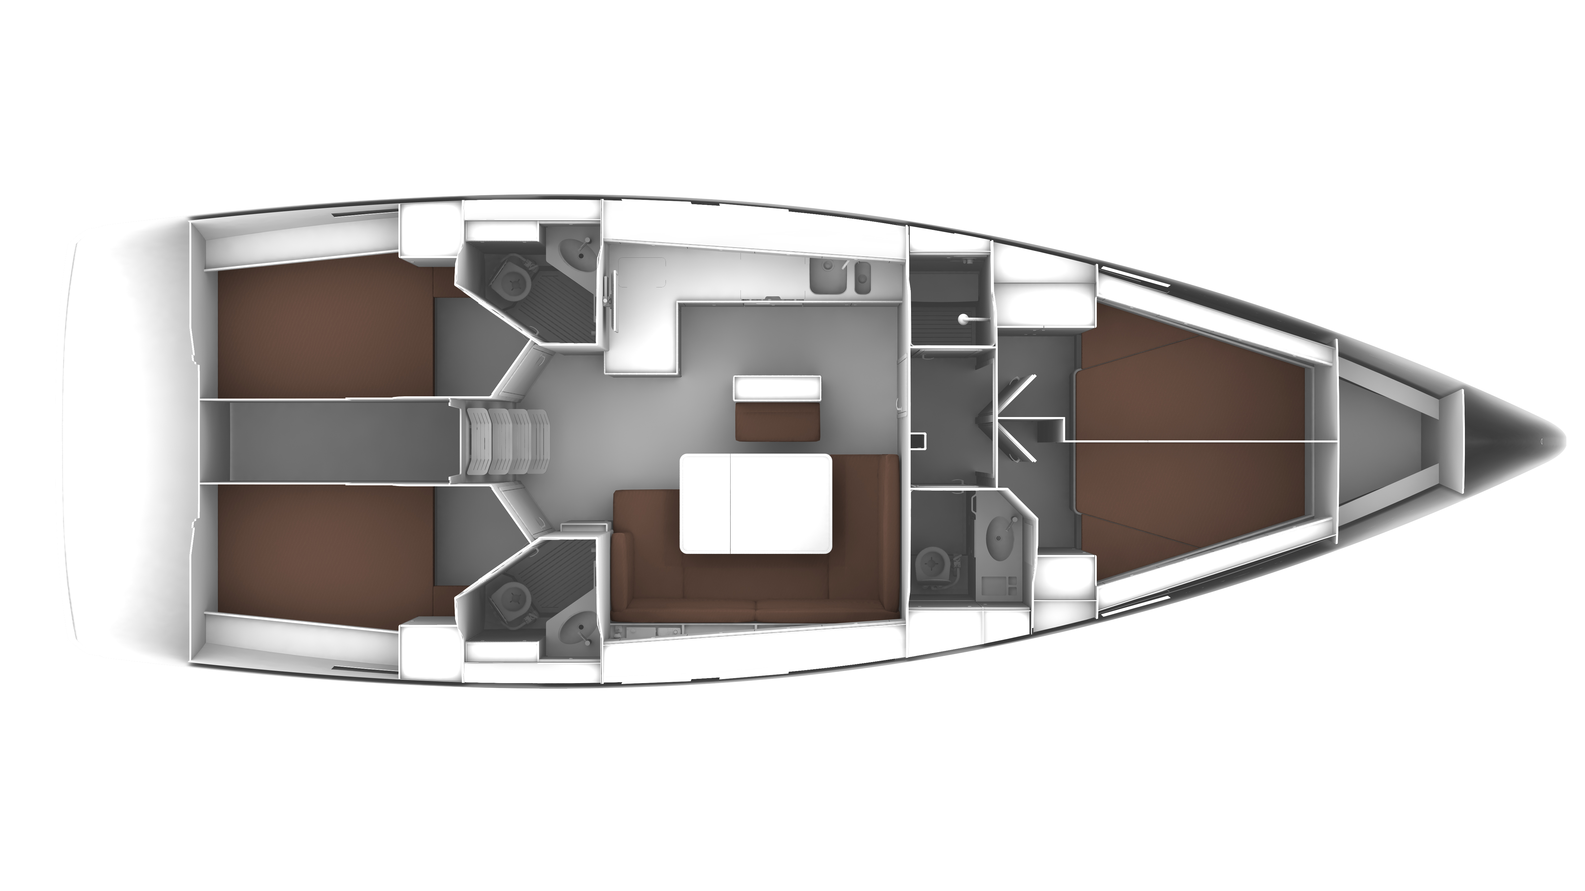

YEAR 2017/2020
Length overall 14,27 m | Cabins 4
Beam 4,35 m | Berth 8 + 1
Displacement 12.600 kg | Draft 2,10 m
Water capacity 360 l | Engine Volvo Penta 75 HP
Fuel capacity 210 l | Sail area 108 m²
EQUIPMENT  - Tender  - Hot water  - Cockpit table  - Roll main sail and roll genoa  - Electric windlass  - Bimini top  - Sprayhood | ELECTRICAL EQUIPMENT  - GPS with plotter  - Autopilot  - Speed and echo log  - VHF  - Radio-CD player  - Wind instrument  - Bow thruster  - Aircondition (only 2020 model)  - Generator (only 2020 model)
OUTSIDE  - 2 winch handles  - 2 anchors with chain  - ropes  - 6 fenders  - boat hook  - wind direction indicator  - life bouy  - 2 gas bottles  - byboat pump  - water nose + brush  - bilge pump + handle | INSIDE  - charts  - plotters + divider  - hand bearing compass  - binoculars  - pilot books  - life jackets  - first aid kit  - portable lamp  - tools  - clock + barometer  - kitchen equipment

