

BAVARIA CRUISER 51 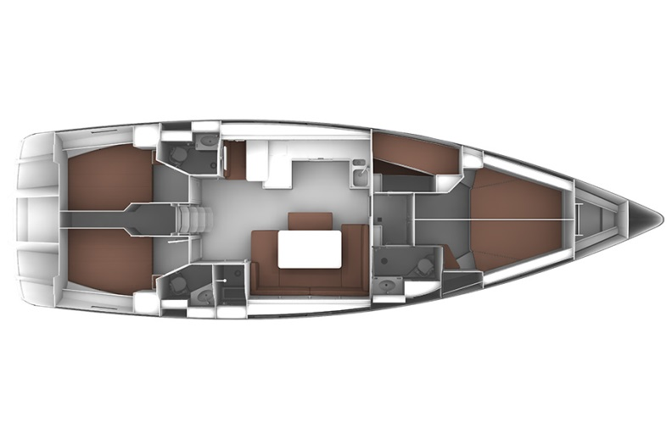
YEAR 2015/2018

Length overall 14,99 m | Draft 1,85 m
Beam 4,67 m | Engine Volvo 75 hp
Displacement 14100 kg | Sail area 131 m2
Water capacity 560 l | 5 cabins, 3 toilets
Fuel capacity 280 l
EQUIPMENT  - Tender  - Bimini top  - Spray hood  - Bow thruster  - Heating  - Hot water  - Cockpit table  - Roll main sail and roll genoa | ELECTRICAL EQUIPMENT  - GPS with plotter  - Autopilot  - Speed and echo log  - VHF  - Radio-CD player + TV/DVD player (Yolo)  - Electric windlass  - Wind instrument  - Heating  - A/C (on My Way One) in saloon- works only when connected on shore power
OUTSIDE  - 2 winch handles  - 2 anchors with chain  - ropes  - 6 fenders  - boat hook  - wind direction indicator  - life bouy  - 2 gas bottles  - By boat pump  - water nose + brush  - bilge pump + handle | INSIDE  - charts  - plotters + divider  - hand bearing compass  - binoculars  - pilot books  - life jackets  - first aid kit  - portable lamp  - tools  - clock + barometer  - kitchen equipment

